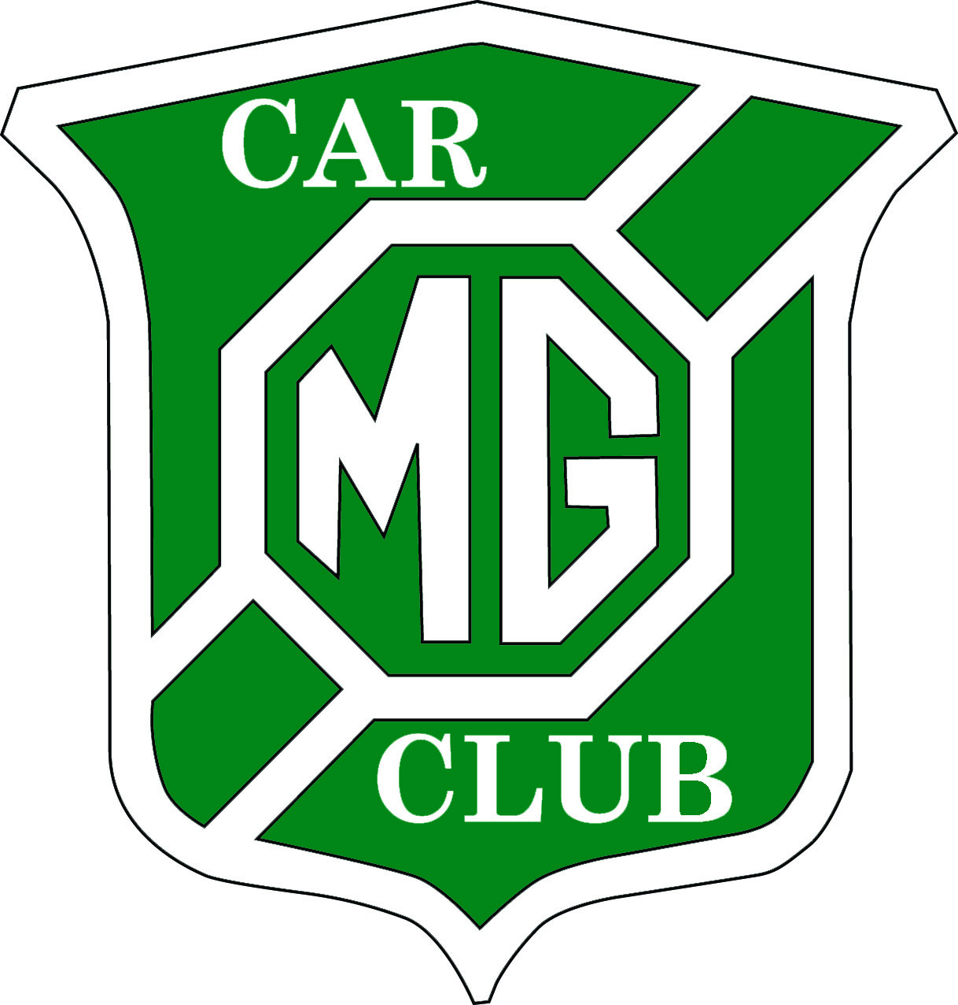
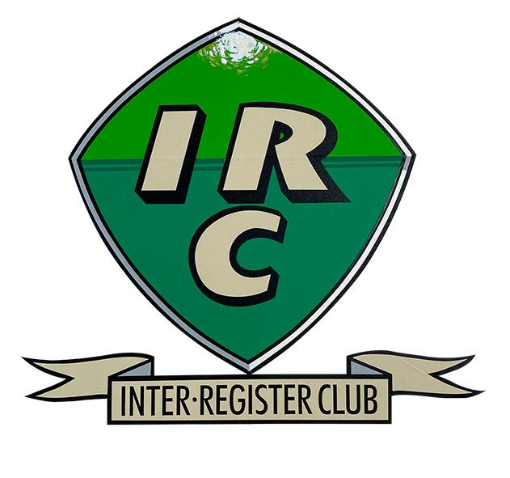
M.G. Car Club Ltd (Midlands Centre) and Inter Register Club
Navigational Regularity 12-car Rally
Saturday 12 September 2026

This Navigational 12-car Rally will take place in Herefordshire and will be based to the west of Ledbury at Westons Cider Mill at Much Marcle,.using OS 1:50,000 Map 149.

The Event will commence at approx.11.00 am with return to the start venue by 14.00. Total distance will be 50 miles on tarmac roads at average speeds of 18 mph for prewar cars and 24 mph for modern cars. Navigation will be very simple and straightforward.

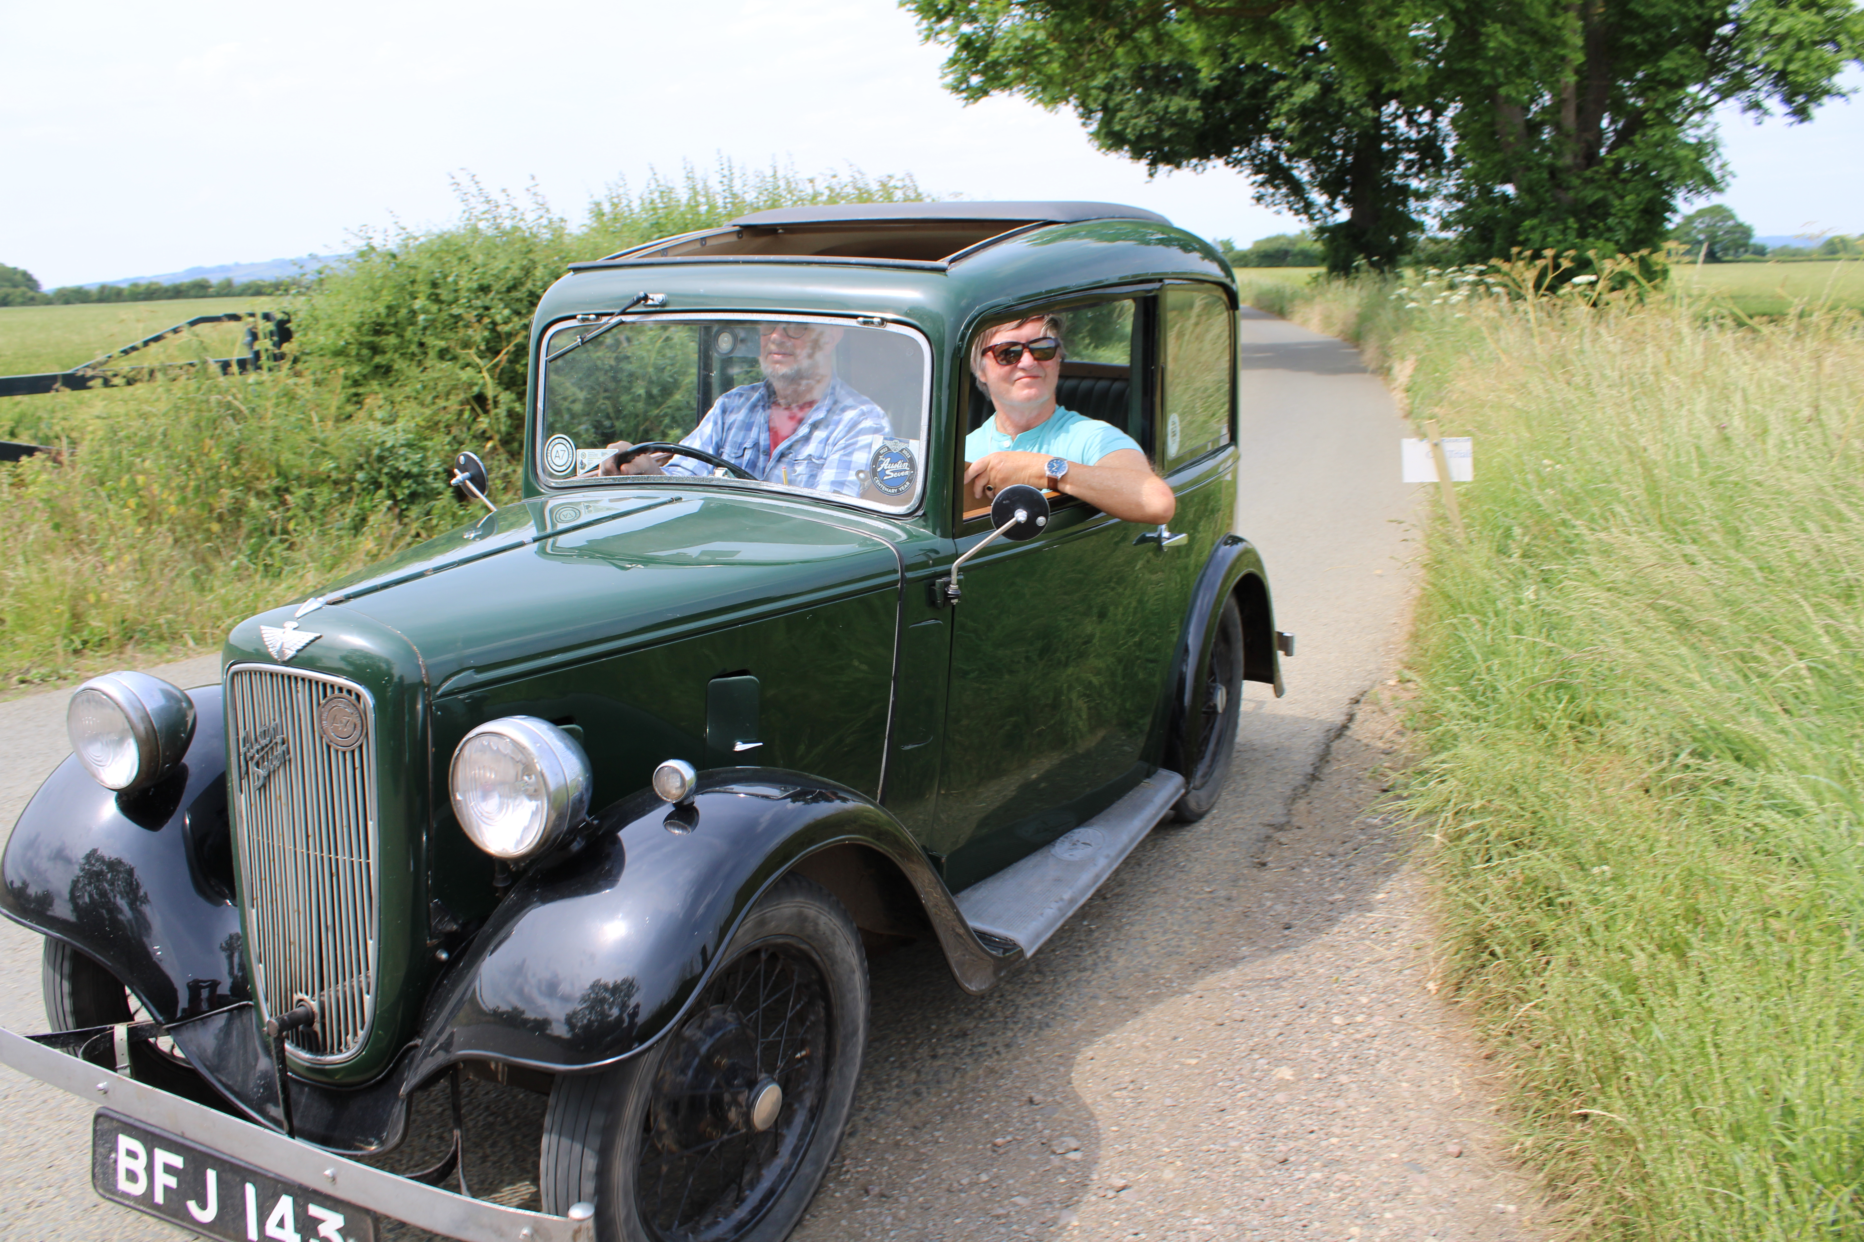
This event will be a round of the Inter Register Club Championship, which will see entries from pre-war cars such as Riley, Alvis, Austin, Humber, Sunbeam, as well as MG’s.
Separate classes will accommodate more modern cars.

Invited Clubs will include HRCR, and VSCC (who have their Madresfield Driving Tests, Malvern event the following day), 60 & Worcester Motor Club,

The Entry fee will be £36. For further information contact Bob Blackstock by e-mail blackstocks2000@aol.com for Supplementary Regulations and Entry Forms. Or visit www.mgccmidlandcentre.co.uk

